Ukrainian-American businessman and computer programmer

He is the co-founder and former CEO of WhatsApp

San Jose State University

He also joined w00w00, a computer security think tank started in 1996

https://www.google.com/search?q=jankoum&rlz=1C1CHBF_enIN976IN976&oq=jankoum&gs_lcrp=EgZjaHJvbWUyBggAEEUYOTIPCAEQLhgKGIMBGLEDGIAEMgkIAhAAGAoYgAQyCQgDEAAYChiABDIJCAQQABgKGIAEMgkIBRAAGAoYgAQyCQgGEAAYChiABDIJCAcQABgKGIAEMgkICBAAGAoYgATSAQgyOTA5ajBqN6gCALACAA&sourceid=chrome&ie=UTF-8#wptab=si:ALGXSlbliz0ICRU0Dyfzzi8Mg2XhN8RDCMGROmK2b8gD1GV62atwgq_LAX1BYNZRmolhf6P4QBjWbTZ-7HsE4QkLruBCmkk-AWCb-PoJvUs-gQRQlxeDgpuqNsUFenzONhvQ-OO4-hg0

Jan Koum bought an iPhone in January 2009 and soon realised the app industry's potential on few months old App Store

February 24, 1976 ,Kyiv, Ukraine

In 2014, Facebook made WhatsApp’s co-founders an offer they couldn’t refuse: $19 billion dollars

current living in Atherton, California

single, also a drop out current age 47

n February 1996, a restraining order was granted against Koum in state court in San Jose, California. An ex-girlfriend detailed incidents in which she said Koum verbally and physically threatened her. In October 2014, Koum said about the restraining order, "I am ashamed of the way I acted and ashamed that my behavior forced her to take legal action

https://en.wikipedia.org/w/index.php?title=Jan_Koum&oldid=1093767558

WhatsApp is headquartered in Menlo Park, 1601 Willow Rd, United States, and has 1 office location.

Company is registered in Hyderabad (Uttar Pradesh) Registrar Office. Whatsapp Application Services Private Limited registered address is FLAT NO. 1,3RD FLOOR,1BHK,PINK ROSE APPT. SARFABAD, SECTOR-23,GAUTAM BUDDH NAGAR,Gautam Buddha Nagar-201301,UP.

Ken Dus

ken@whatsapp.com

94%

Save as lead

8 sources

ip@whatsapp.com

93%

Save as lead

20+ sources

android-support@whatsapp.com

93%

Support

Save as lead

20+ sources

bd@whatsapp.com

93%

Save as lead

20+ sources

wp-support@whatsapp.com

92%

Support

Save as lead

20+ sources

suport@whatsapp.com

92%

Save as lead

19 sources

suporte@whatsapp.com

92%

Support

Save as lead

20+ sources

emailsupport@whatsapp.com

91%

Support

Save as lead

20+ sources

rr@whatsapp.com

91%

Save as lead

17 sources

iphone-support@whatsapp.com

91%

Support

Save as lead

20+ sources

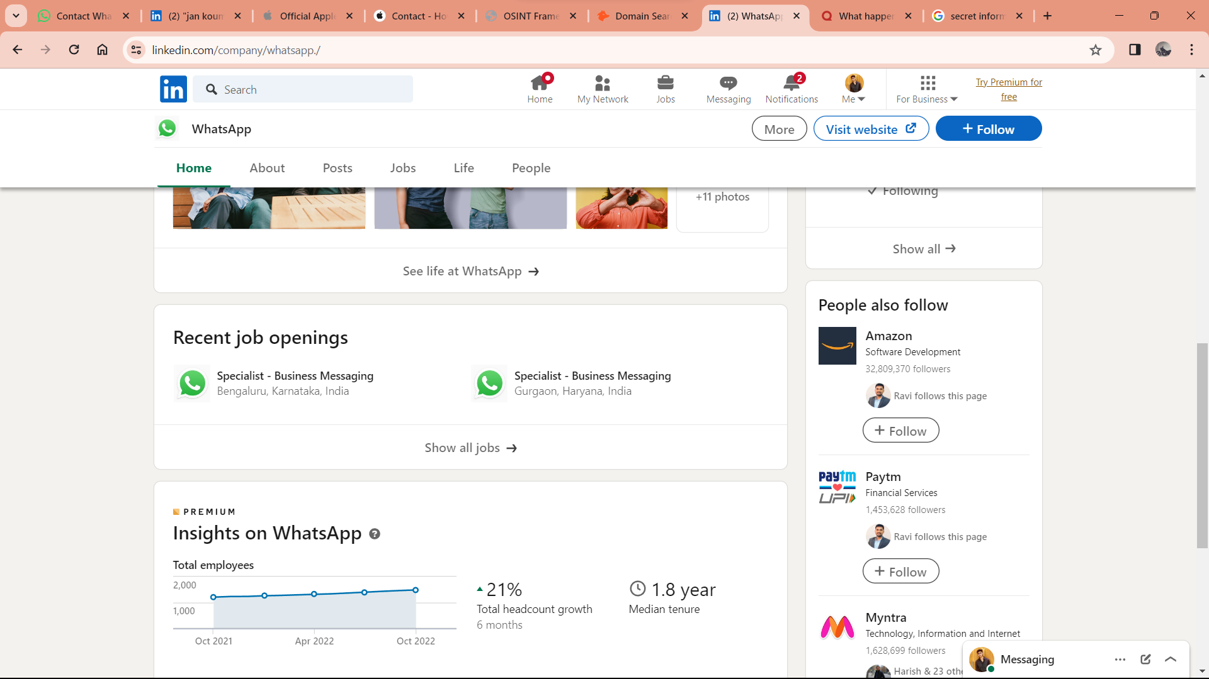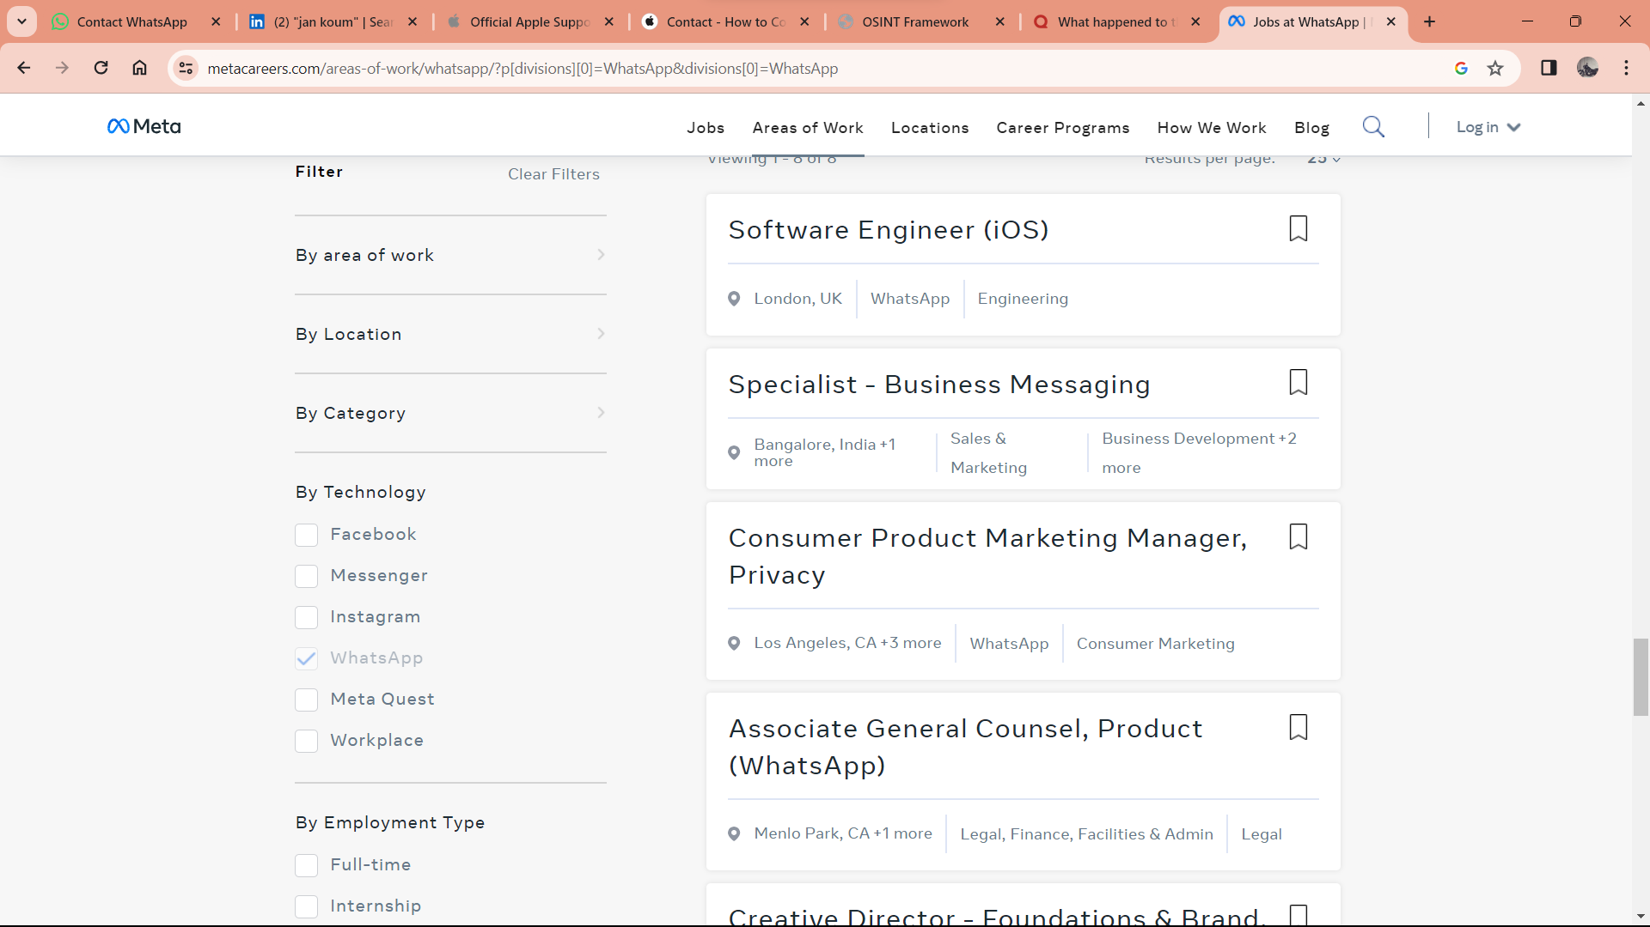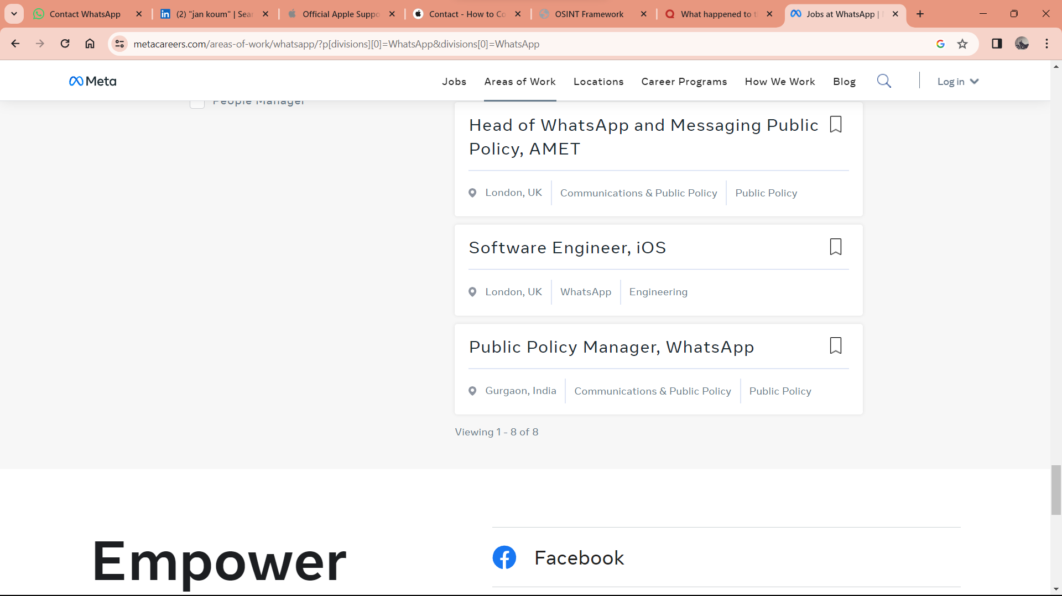

[https://www.metacareers.com/areas-of-work/whatsapp/?p[divisions][0]=WhatsApp&divisions[0]=WhatsApp](https://www.metacareers.com/areas-of-work/whatsapp/?p%5bdivisions%5d%5b0%5d=WhatsApp&divisions%5b0%5d=WhatsApp)

nearest ping to whatsapp.com

157.240.23.53

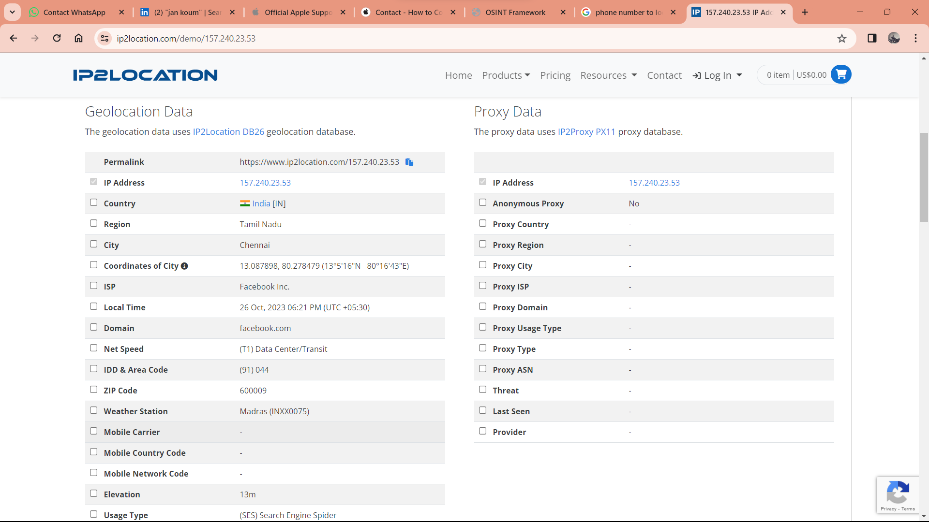https://www.ip2location.com/demo/157.240.23.53